**Simulasi Percobaan**

1. Distorsi

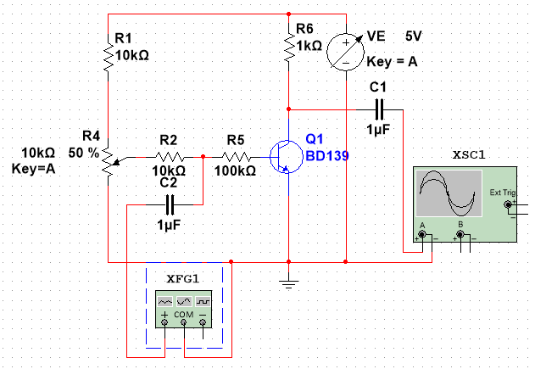

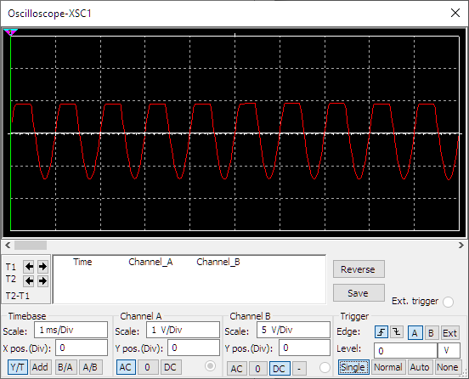

1. Feedback Negative

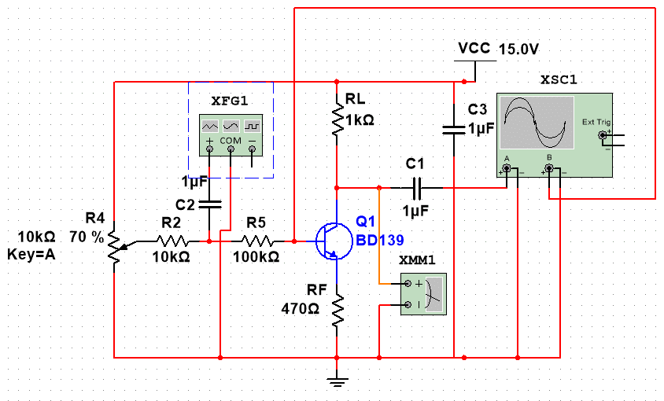

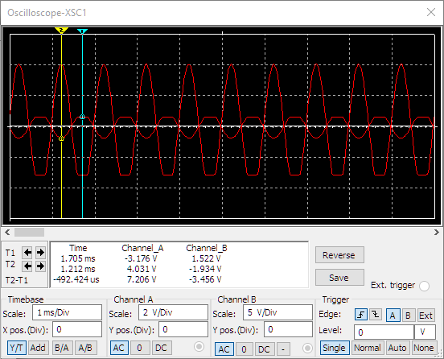

RF/RL = 470/1000 = 0.47

V Y1 (keluaran) = 7,206V | V Y2 (masukan) = 3,456V

Gain = 7,206V/3,456V = 2,085069 = 2,09

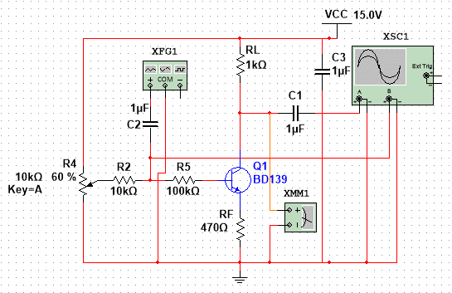

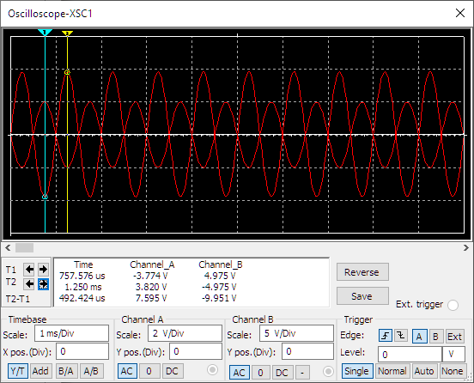

V(A) = 9,951V, V(B) = 7,595V

R(in) = V(B)/(V(A)-V(B)) = 7,595/(9,951-7,595) = 523,9kOhm

1. Respon Frekuensi

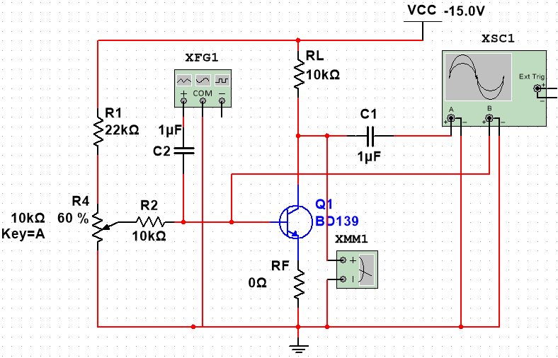

|  |  |  |  |  |
| --- | --- | --- | --- | --- |
| Frekuensi | Voltage Gain | | Phase Change (Degrees) | |
|  | **Rf = 0** | **Rf = 220 Ohm** | **Rf = 0** | **Rf = 220 Ohm** |
| 1 kHz | 0.99713 | 0.99714 | 0 | 0 |
| 5 kHz | 0.99714 | 0.99714 | 0 | 0 |
| 10 kHz | 0.99713 | 0.99713 | 0 | 0 |
| 30 kHz | 0.99701 | 0.99714 | 0 | 0 |
| 60 kHz | 0.99713 | 0.99701 | 0 | 0 |
| 100 kHz | 0.99702 | 0,99700 | 0 | 0 |

1. Inverter

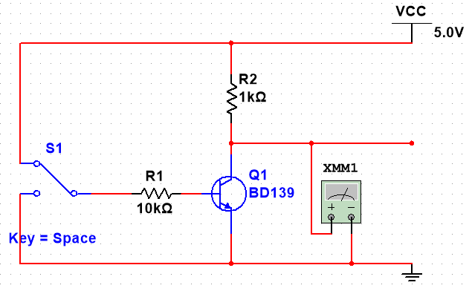

|  |  |
| --- | --- |
| **Input** | **Output** |
| 0 (Gnd) | 1 (5v) |
| 1 (5v) | 0 (28,071mV) |